**Aim: Create a Snapshot of a VM and Test it by loading the Previous Version/Cloned VM**

**Step 1:** Create a virtual machine.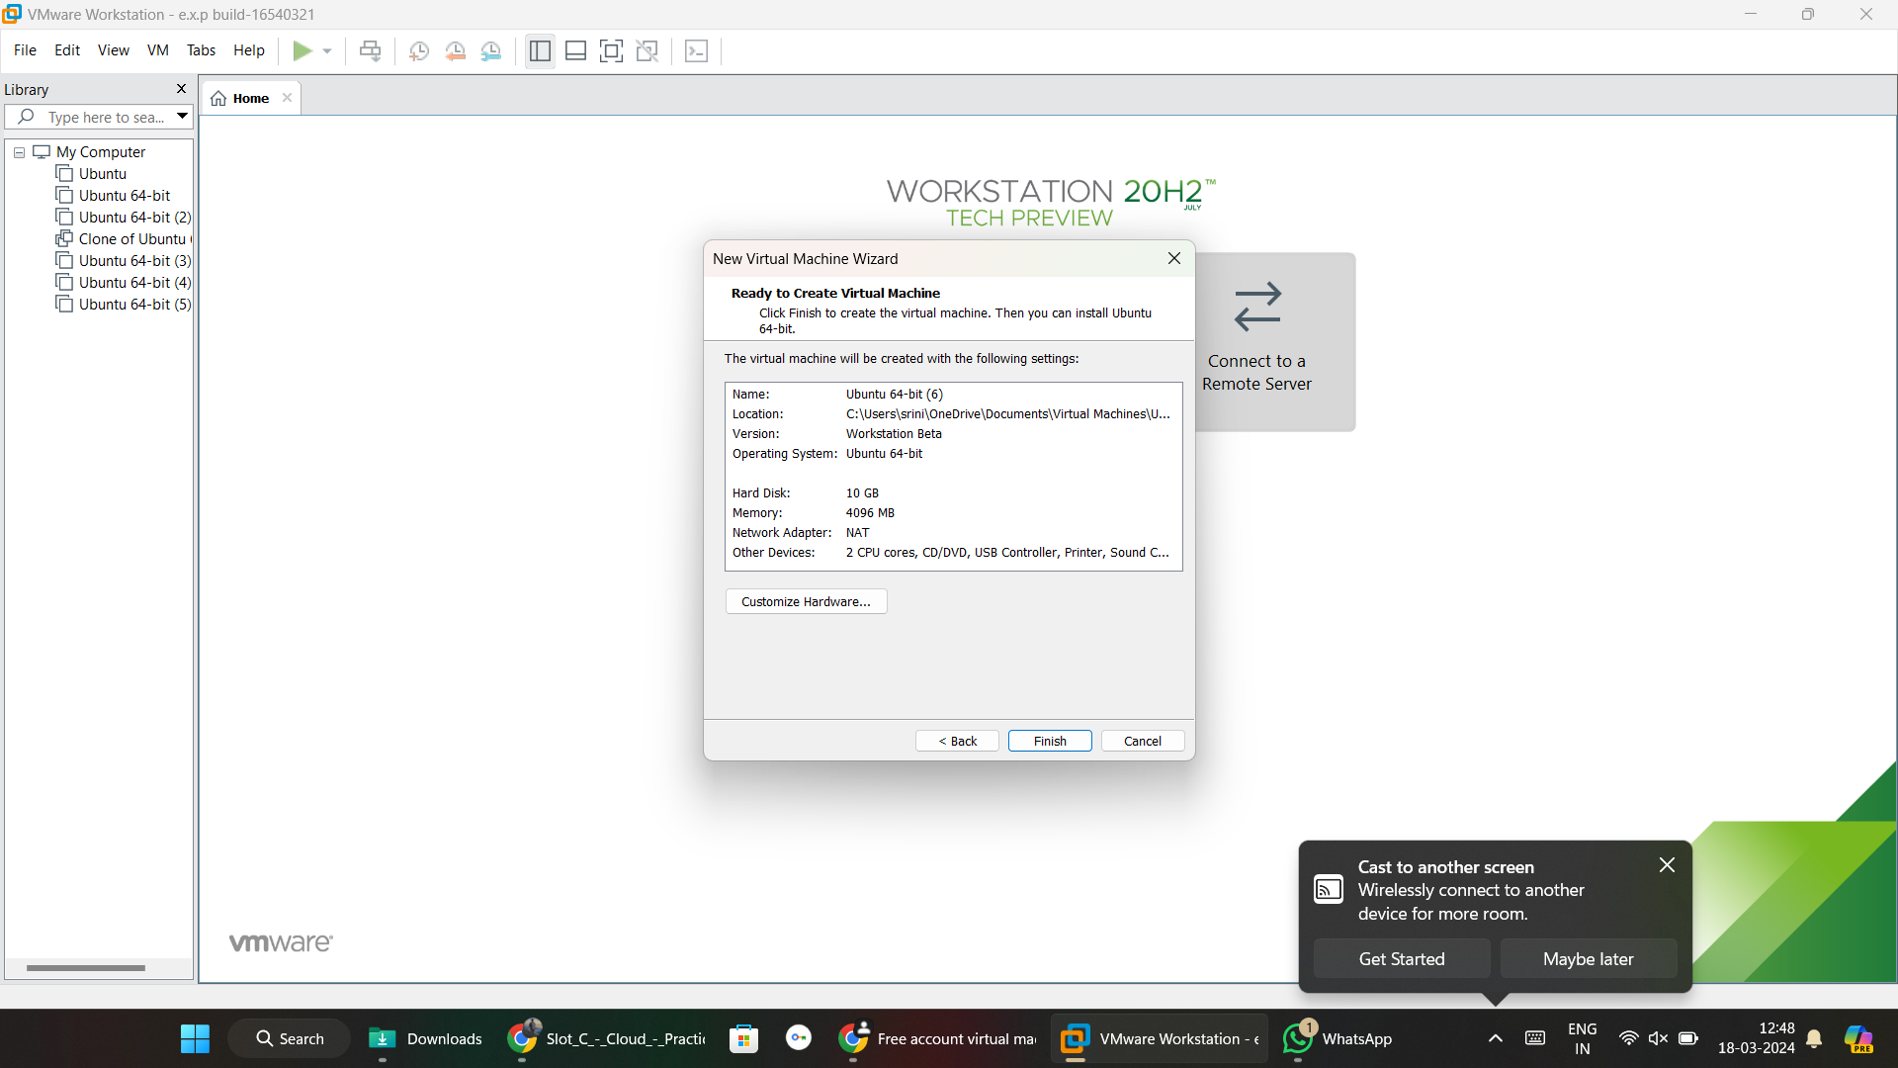

**Step 2:** click snapshot and take it.

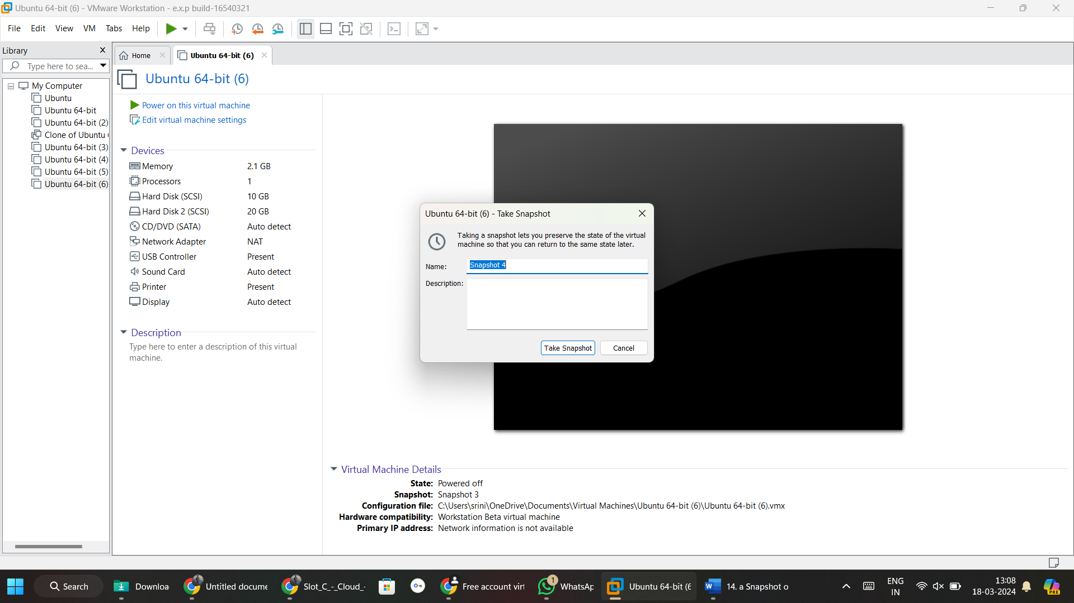

**Step 3:** Click snapshot manager and we see snaps which we taken.

